This project is aimed to implement a RDAP protocol which is discussed in IETF weirds group (See https://datatracker.ietf.org/wg/weirds/), named RDAP Server.

Overview

Architecture
Architecture of RDAP Server is shown as Figure 1.1-1.
Figure 1.1-1 RDAP Server Architecture
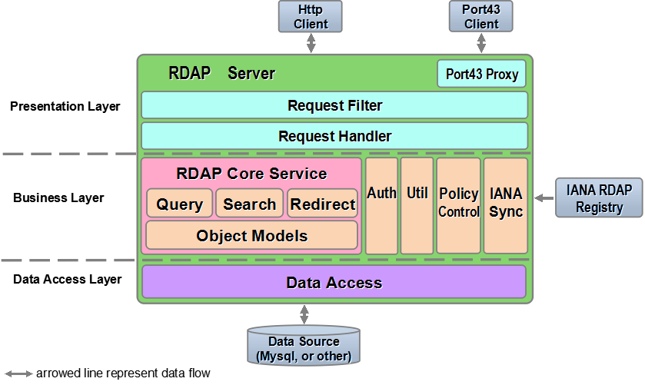
RDAP Server is composed of Presentation Layer, Business Layer and Data Access Layer.

Overview of Modules
- Presentation Layer
  - Port43 Proxy: proxy for port43-whois-client conforms to [RFC3912].
  - Request Filter: limit rate (see section2.1.2), handle request with non-HTTP GET method.
  - Request Handler: parse request, and write query result to client.
- Business Layer
  - RDAP Core Service
    - Query: query registration data by exactly matching.
    - Search: search registration data.
    - Redirect: redirect service for non-authoritative objects of this registry, see [I-D.ietf-weirds-redirects].
    - Object Models: object models corresponding to Object Class in RDAP JSON response, see [I-D.ietf-weirds-json-response].
  - Auth: authentication and authorization.
  - Util: validate query parameter, and convert data format.
  - Policy Control: used to hide some columns of object according to registry’s policy.
  - IANASync: synchronize ‘Redirect Table’ from IANA’s ‘RDAP Registry’, ‘Redirect Table’ is used in Redirect module (see section 2.2.3).
- Data Access Layer
  - Data Access: access data from data source.

Related Outer Objects
- Client: client of RDAP Server.
- Data Source: data source of RDAP Server.
- IANA RDAP Registry: ‘Redirect Table’ used for Redirect service is synchronized from RDAP Registry in IANA, see [I-D.ietf-weirds-redirects].

Query Process
For illustrative purposes, a domain query process by a logined client is shown as following Figure 1.1-2.
- Client send a domain query request ‘/domain/cnnic.cn’ to RDAP Server.
- Request Filter check whether visits frequency from this client exceeds the system limit.
- If the check is passed, Request Filter forward this request to Request Handler.
- Request Handler parse the request Uri and obtain query type (see section 2.1.3) - ‘domain’.
- Request Handler call Query module.
- Query module check the validity of request parameter – domain name ‘cnnic.cn’, by calling DomainUtil in Util module.
- If query parameter is valid, then Query module call Data Access module.
- Data Access module query data from data source, and return data to Query module.
- Query module call Policy Controller to remove some columns from result according to policy. See section 2.2.3.
- Query module call Auth module, Auth module remove columns which is not accessible to this client, and remove columns which is not allowed to display according to registry’s policy (see section 2.2.2.2).
- Request Handler format result data to JSON by calling Util module.
- Request Handler write result data to client.
Figure 1.1.3-1 Domain query process
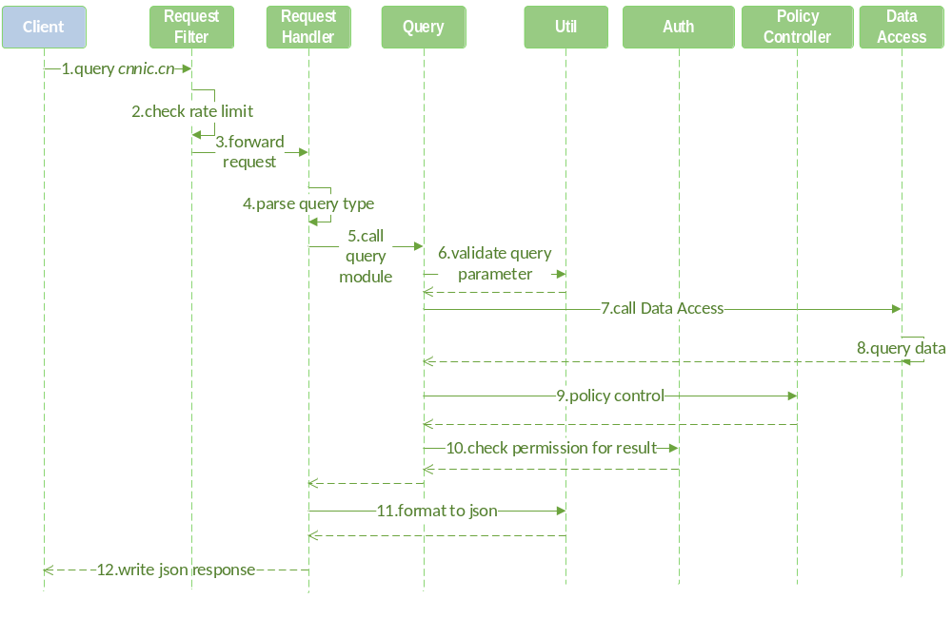

RDAP Server Modules

Presentation layer
Presentation Layer is designed to display the user interface and manage user interaction.

Port43 Proxy
Port43 Proxy is a user interface which is able to accept client queries via port 43, conforms to [RFC3912].
Port43 Proxy transmits port43 queries to HTTP queries that can be accepted by Request Filter (see section 2.1.2).

Request Filter
Request Filter is designed to manage interaction with client.
Figure 2.1.2-1 Request Filter class
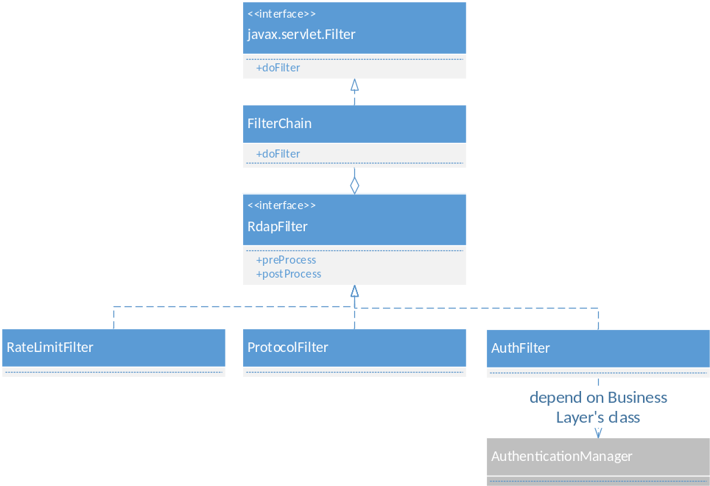
Description of class:
- Javax.servlet.Filter: servlet filter interface. Request Filter module depend on servlet filter.
- FilterChain: contains all filters in RDAP Server, and invoke them to filter request.
- RDAPFilter: filter interface for all filters in RDAP Server. It has two methods to be implemented:
  - preProcess: this is called before process service.
  - postProcess: this is called after process service.
- RateLimitFilter and ProtocolFilter: implementation of RDAPFilter.
  - RateLimitFilter: prevents highly frequent queries, it returns 429 error to client if query interval is shorter than the configured interval.
  - ProtocolFilter: handle request with non-HTTP GET method, and it will return error to client.
  - AuthFilter: authenticate, and obtain authentication information from client.

Request Handler
Request Handler is front controller of RDAP Server.
Figure 2.1.3-1 Request Handler class
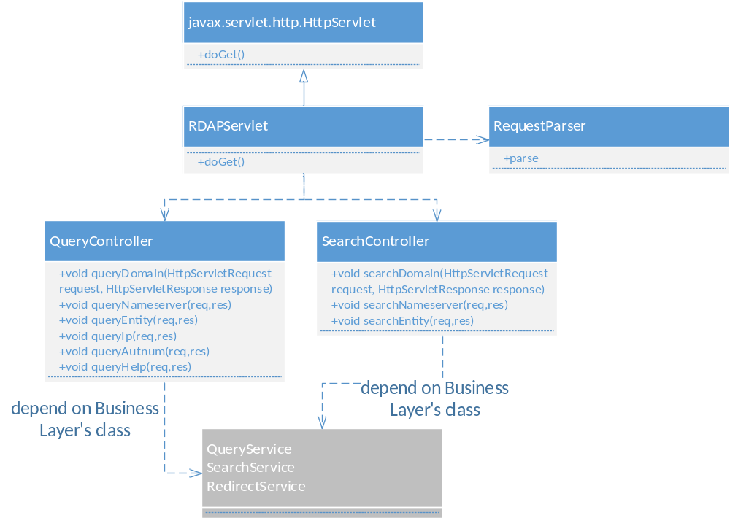

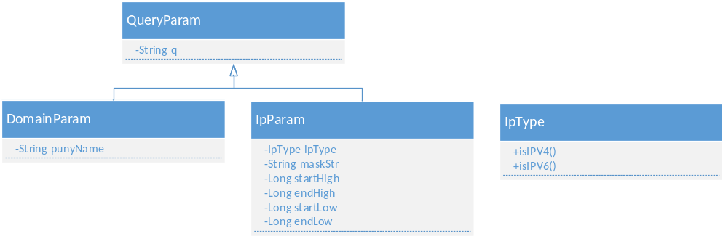
Description of class:
- javax.servlet.http.HttpServlet: servlet class in javax.servlet, see http://docs.oracle.com/javaee/5/api/javax/servlet/package-summary.html.
- RDAPServlet: RDAPServlet is entrance of RDAP Server, and it’s a standard java servlet. It uses RequestParser to parse request, then dispatch request to QueryController and SearchController, and finally return result to client. Method:
  - doGet: override HttpServlet’s method.
- RequestParser: parse request, obtain query type from Uri. There are 8 query types, according to [I-D.ietf-weirds-query]:
  - Lookup type: domain/ip/autnum/nameserver/entity
  - Search type: domains/nameservers/entities
- QueryController: control query process. Query process:
Figure 2.1.3-2 QueryController process
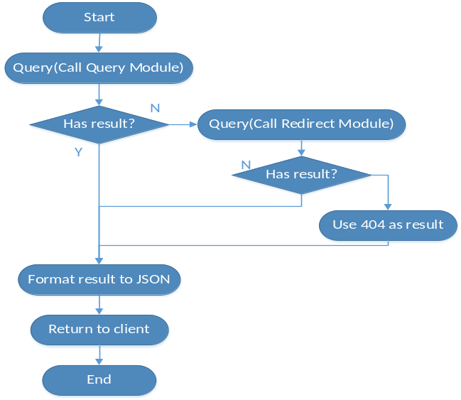
- SearchController: control search process, and process is similar with QueryController.
- QueryParam: query parameter base object, and ‘q’ is primitive parameter from client.
- DomainParam: domain query parameter, and ‘punyName’ is puny name of domain.
- IpParam: ip query parameter. Fields:
  - IpType: IP V4 or IP V6.
  - maskStr: query parameter for ip net mask.
  - startHigh, endHigh, startLow, endLow: ip is stored with number format in RDAP Server.
    - startHigh: used for IP V6, represent high 64 bit of net start address of IP V6.
    - endHigh: used for IP V6, represent high 64 bit of net end address of IP V6.
    - startLow: used for IP V4 and V6, represent low 64 bit of net start address of IP V6, or net start address of IP V4.
    - endLow: used for IP V4 and V6, represent low 64 bit of net end address of IP V6, or net end address of IP V4.
- IpType: IP V4 or IP V6.

Business Layer

RDAP Core Service
RDAP Core Service is core of RDAP Server, it contains Query, Search, Redirect, and Object Models.

Query
Query module is designed to lookup registration objects. Class diagram is shown as following figure.
Figure 2.2.1-1 Query module class
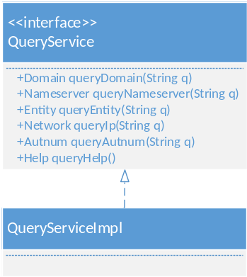
Process of method ‘queryDomain’:
- Validate query parameter by calling DomainUtil (in Util module, see section 2.2.1.5).
- May convert U-labels to A-labels if domain contains U-labels, see [RFC5891]. This is done also by calling DomainUtil.
- Call QueryDao (in Data Access module, see section 2.4.1) to query result.
- Call AccessDecisionManager (see section 2.2.2.2) to check permission for result data.
- Call Policy Control to remove some columns according to policy.
- Return result.
Other method’s process is similar with queryDomain.

Search
Search module search data for middle-or-tailing-wildcard pattern, eg: cnnic*.cn or cnnic*. Class diagram is shown as following figure.
Figure 2.2.1-2 Search module class
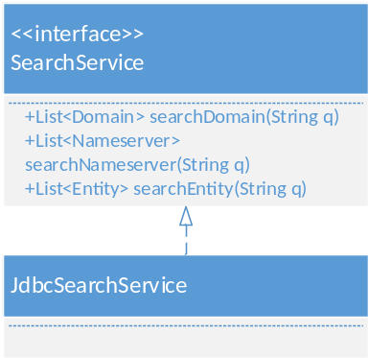
JdbcSearchService is default implementation by using database native search feature. This implementation can be replaced by writing other implementation such as solr if necessary (see section 3.3).
Process of method ‘searchDomain’:
- Validate query parameter by calling DomainUtil (in Util module, see section 2.2.1.5).
- May convert U-labels to A-labels if domain contains U-labels, see [RFC5891]. This is done also by calling DomainUtil.
- Call SearchDao (in Data Access module, see section 2.4.1) to search result.
- Call AccessDecisionManager (see section 2.2.2.2) to check permission for result.
- Call Policy Control to remove some columns according to policy.
- Return result.
Other method’s process is similar with searchDomain.

Redirect
Redirect module is designed to query authoritative RDAP server information for non-authoritative query of this RDAP Server. This is done by querying a ‘Redirect Table’, which is synchronized from IANA RDAP Registry periodically, see [I-D.ietf-weirds-bootstrap].
Figure 2.2.1-3 Search module class
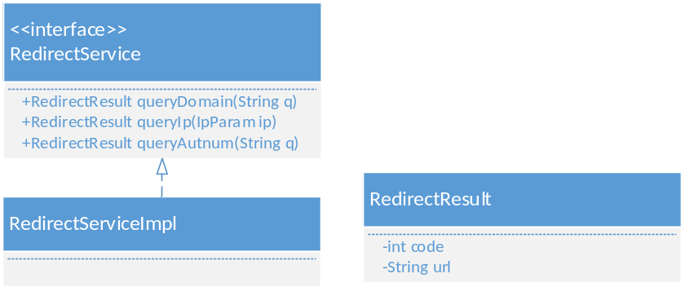
Description of class:
- RedirectService: interface for Redirect Module.
- RedirectServiceImpl: implementation of RedirectService.
- RedirectResult: represents return value.

Object Models
Object Models class is shown as following figure. Some joined-objects is not included.
Figure 2.2.1-4 Object Models class
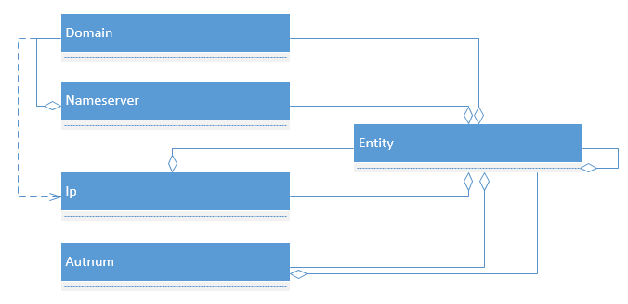
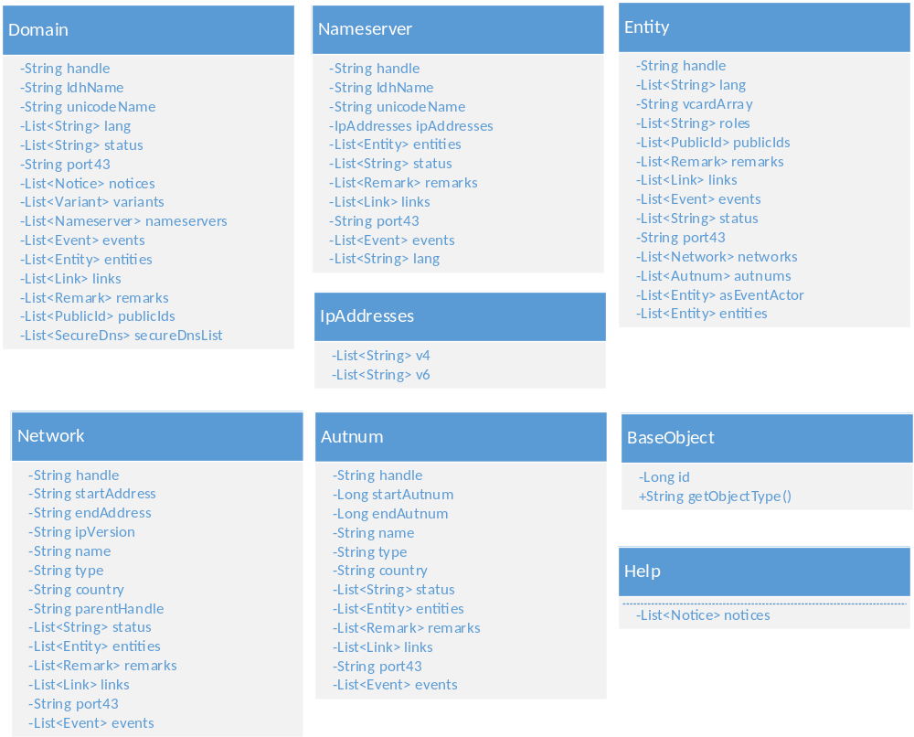
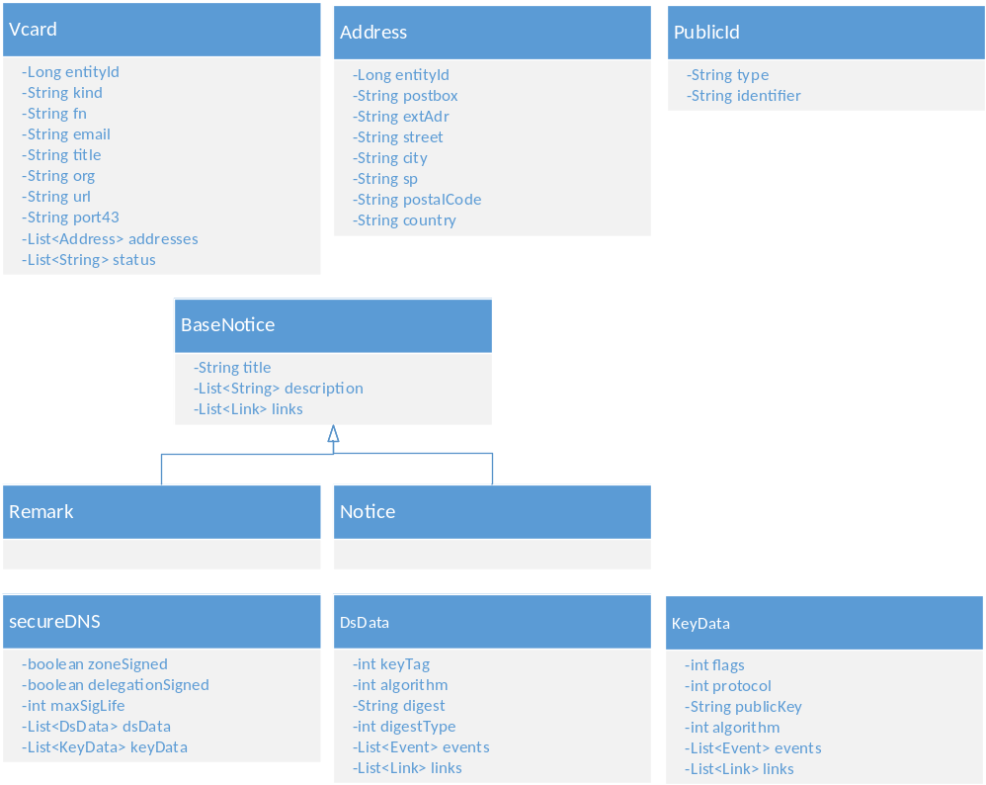
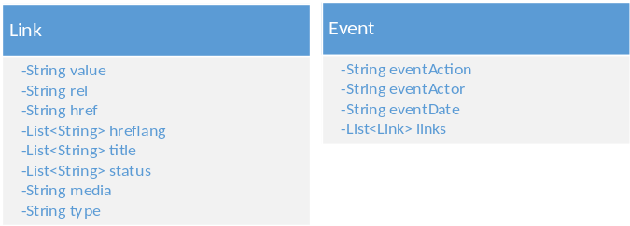
- Nameserver doesn’t contain entity when nameserver is in domain object.
- Entity doesn’t contain ip (network) and autumn when entity is nested object in other object.

Util
Util module contains validate and data convert utility.
Figure 2.2.1-5 Util class
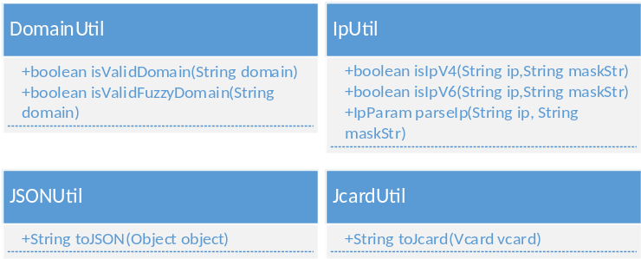
- DomainUtil: validate a-label/u-label domain according to [RFC1035] and [RFC5891].
- IpUtil: validate ipv4/ipv6; convert ip from/to long-format value, for query purpose.
- JsonUtil: format data to JSON format.
- JcardUtil: format entity information to Jcard (see [I-D.ietf-weirds-json-response]) format.

Auth
Auth module is used for authentication and authorization.

Authentication
Authentication module has a default implementation by using HTTP Basic + TLS, see [I-D.ietf-weirds-RDAP-sec], this can be replaced by other implementation (see section 3.4).
Figure 2.2.2-1 Authentication class
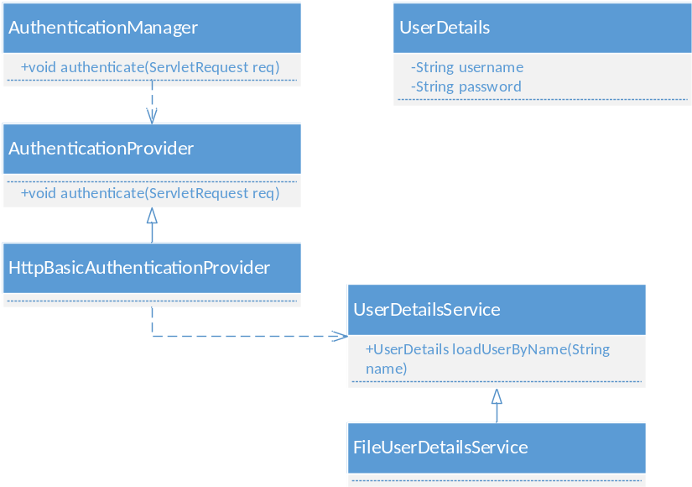
- AuthenticationManager: handle authentication, store authenticated information into session after login, and clear this session after logout, using ‘authenticate’ method.
- AuthenticationProvider: interface to provide authentication.
- HttpBasicAuthenticationProvider: authentication provider of using HTTP Basic authentication.
- UserDetails: user’s information in RDAP Server - username and password
- UserDetailsService: used to load UserDetails.
- FileUserDetailsService: default implementation of UserDetailsService, by loading UserDetails from file.

Authorization
Authorization module is designed to control access to resource in RDAP Server.
Figure 2.2.2-2 Authorization module
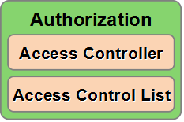

Access Control List
RDAP Server use Access Control List (ACL) for authorization, ACL is a permission control model, see [RFC4949].
ACL model is shown as following figure.
Figure 2.2.2-3 ACL Model
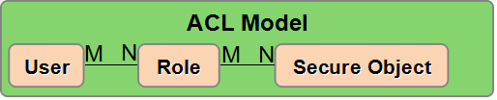
- User: authenticated user.
- Role: role of user.
- Secure Object: resource to be protected. There are two kinds of Secure Object:
- Registration Object: per registration object.
- Uri: protected Uri of RDAP Server, such as ‘/domains’, ‘/nameservers’.

Access Controller
Access Controller is a module to Control access to Secure Object when query or search, non-authorized access will be forbidden.
Figure 2.2.2-4 Access Controller class
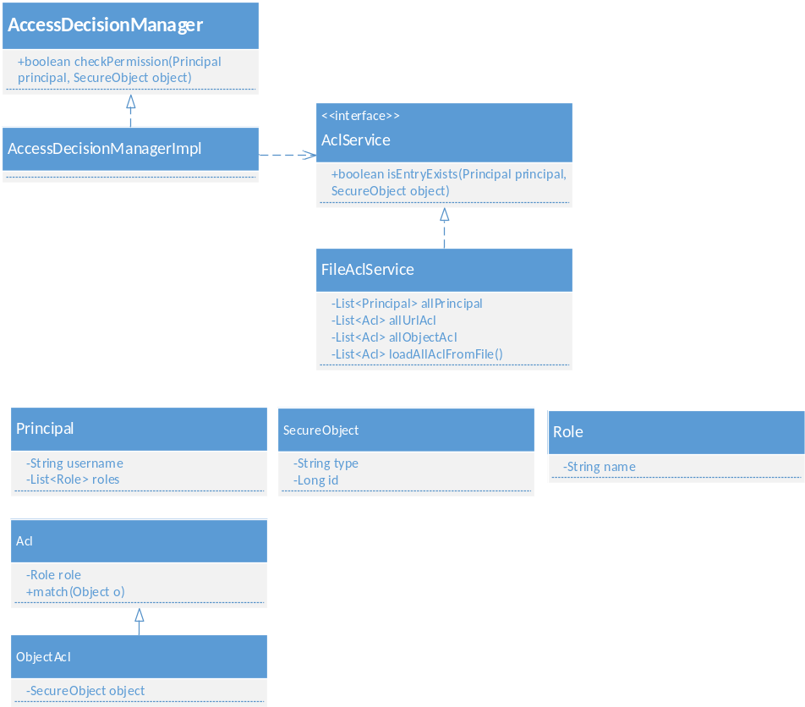
Class description:
- AccessDecisionManager: access control interface.
- AccessDecisionManagerImpl: default implementation of AccessDecisionManager. All Registration object and Uri is readable (or accessible) for all users by default. An authorization entry [user-role-secure Object] will be added when permission control is needed, users who have no entry for this secure object will be forbidden to access this object.
- AclService: used to load ACL entry.
- FileAclService: default implementation of AclService, by loading ACL entry from file, and this can be replaced by other implementation (see section 3.5)
- Principal: client's identity.
- Secure Object: object that need access control.
- Role: role of user.
- Acl: ACL entry, base class.
- ObjectAcl: object type ACL, registration object use this type.

Policy Control
Policy Control is used to hide some columns of object according to registry’s policy.
Figure 2.2.3-1 Policy Control class

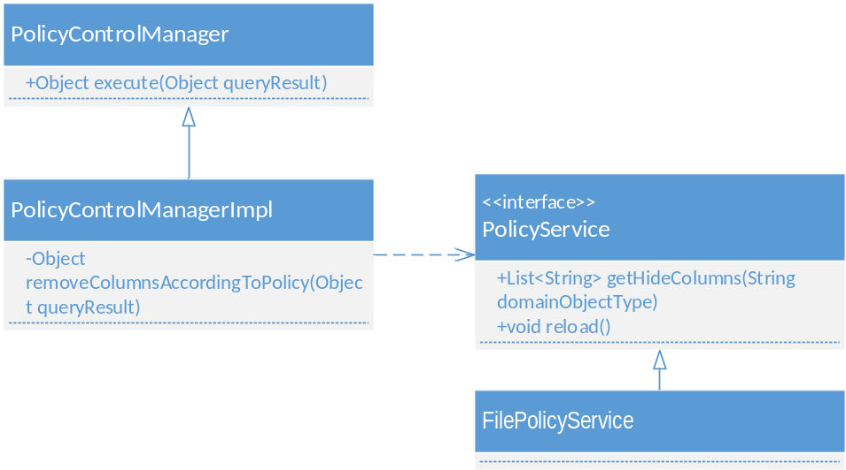
- PolicyControlManager: policy control interface.
- PolicyControlManagerImpl: an implementation of PolicyControlManager. It will remove columns from object according to policy.
- PolicyService: interface for loading policy.
- FilePolicyService: default implementation of PolicyService, by loading policy from file. Every entry in file indicate that one or some columns of object is not allowed to display. This default implementation can be replaced by other implementation (see section 4.6).

IANASync
The Redirect module depends on a ‘Redirect table’, IANASync module is designed to synchronize this Redirect table from IANA periodically.

Data Access Layer
Data Access Layer is designed to access RDAP data from data source.

Data Access
Data Access is aimed at making it easy to work with different data source.
Data Access module has a default implementation for MYSQL database accessing, this implementation can be replaced by writing custom Data Access implementation and providing database SQL dialect for specified database (see section 4.1).
Figure 2.3.1-1 Data Access class
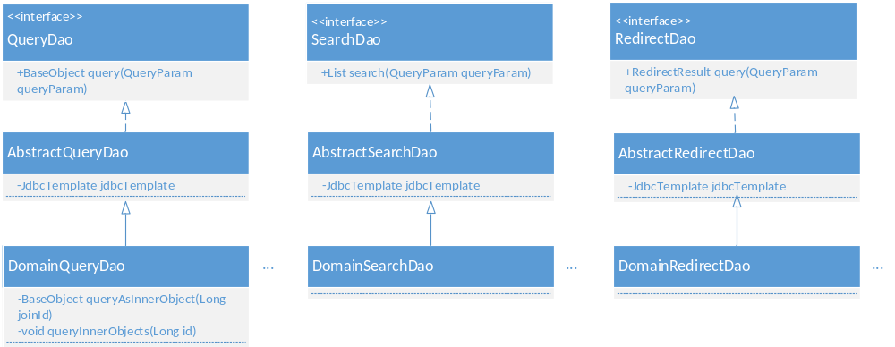
Class description:
- QueryDao: all query DAO interface. Method:
  - query: query by handle/id.
- DomainQueryDao, and other DAO implementation: query DAO implementation, each Object Model has one DAO. Method:
  - queryAsInnerObject: query object as inner object of other object, eg: query this entity object as inner objects in domain object.
  - queryInnerObjects: query inner objects in this object, eg: query entity objects in this domain object.
- SearchDao: all search DAO interface. Method:
  - search: search by parameter.
- DomainSearchDao, NsqueryDao, EntitySearchDao: search DAO implementation, using database native ‘like’ comparisons, use b-tree index.

Figure 2.3.1-2 Query DAO implementation class
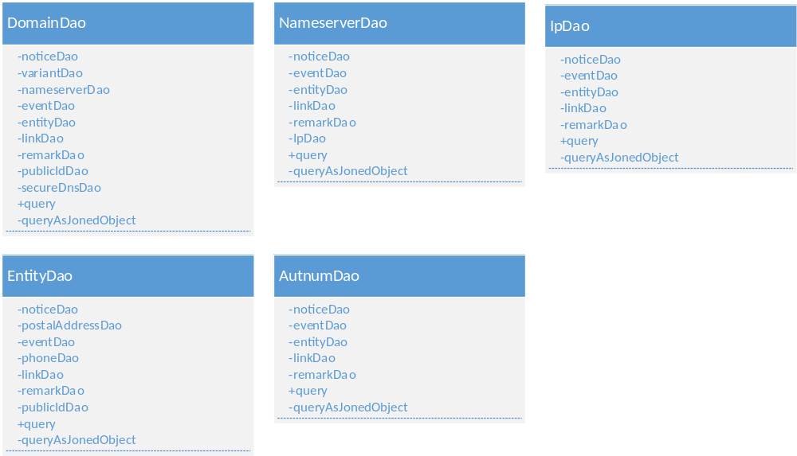

Related Outer Object
Related outer object to RDAP Server.

Data Source
Data source of RDAP Server, default is MYSQL database, can be replaced by specified data source if Data Access implementation is replaced by corresponding data source (see section 4.1).

Client
Send query/search request to RDAP Server, and get response.
- Http Client: Client that can direct access to RDAP Server use HTTP1.1, eg: using Linux command ‘wget’ or ‘curl’ to send request to RDAP Server.
- Port43 Client: Client that can access WHOIS service via port 43 conforms to [RFC3912].

IANA
IANA maintains RDAP Registry, see [I-D.ietf-weirds-bootstrap], which is used by RDAP Server’s ‘Redirect Table’ for redirect service.

Physical Deployment
Figure 3-1 Physical Deployment

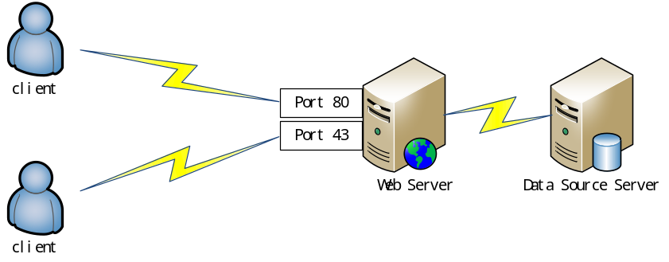
Web Server: Web Container (such as tomcat) with RDAP Server deployment on it. Registry can deploy more than one Web Server to improve performance. (TBD)
Data Source Server: Data Source server, such as MYSQL Server. Registry can deploy more than one Data Source Server to improve performance. (TBD)

Extension

Data Access Extension
Data Access has a default implementation for MYSQL database, it can be replaced by writing custom implementation. Following steps show how to use POSTGRESQL to replace MYSQL implementation.
- Rewrite all DAO, shown as yellow part in following figure, and methods should use POSTGRESQL’s SQL dialect.
Figure 4.1-1 Data Access Extension
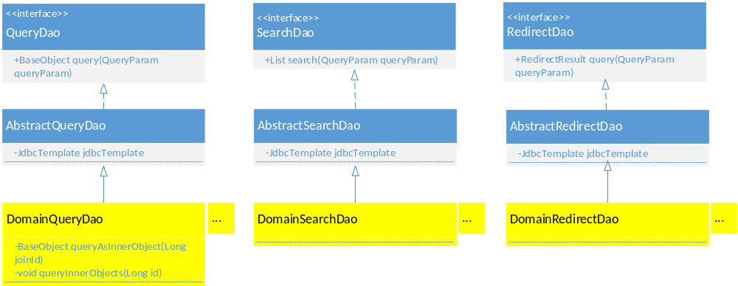
- Add POSTGRESQL’s JDBC driver dependency to maven configuration file - pom.xml in project path (maven is a tool for dependence and building, see http://maven.apache.org).
- Configure JDBC properties in jdbc.properties file in project path.

Column Extension
Registry can add their own custom columns to RDAP Server’s JSON response for registration object, see [I-D.ietf-weirds-json-response], and following steps show how to extend.
- Add custom object model, which should extends original object model, eg: suppose we want to add a column called ‘expire Date’ to Domain, then we add a custom object called ‘CnnicDomain’ as our Domain model, which extends Domain, and add property ‘expireDate’ with its get/set methods to CnnicDomain. Shown as yellow part in following figure.
Figure 4.2-1 Column Extension - Object Model
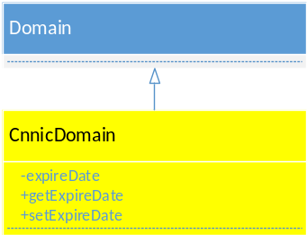
- Configure ‘extendColumnPrefix’ entry in property file in RDAP Server, this entry’s value will show as all extend column’s prefix in JSON response.
- Rewrite Query DAO and Search DAO, to fill the new property with data, and use CnnicDomain where using Domain. Shown as yellow part in following figure.
Figure 4.2-2 Column Extension - Data Access
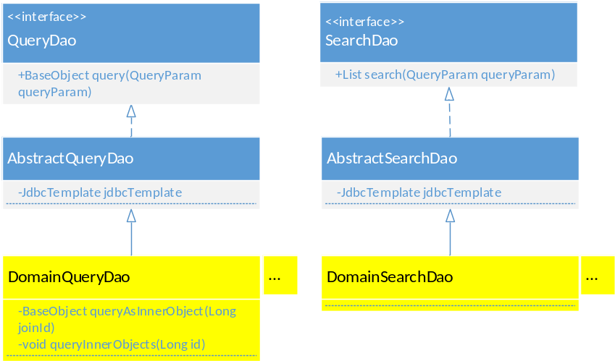
- Add a row to table RDAP_conformance, which will included in JSON response ‘RDAPConformance’ data column following the default value ‘RDAP_level_0’.

Search Extension
Search module has a default implementation by using database native ‘like’ comparisons (see section 2.2.1.2), this implementation can be replaced by writing other implementation such as solr(see http://lucene.apache.org/solr) if necessary, shown as yellow part in following figure.
Figure 4.3-1 Search Extension
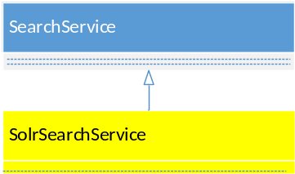

Authentication Extension
Authentication module has a default implementation by using HTTP Basic + TLS, and load user details from file (see section 2.2.2.1), these can be replaced by writing other implementation, following figure show two probable extension.
- JdbcUserDetailsService, by loading user details from database, shown as yellow part in figure 3.4-1.
- DigestAuthenticationProvider, by using HTTP digest authentication instead of HTTP Basic authentication, shown as yellow part in figure 3.4-2.
Figure 4.4-1 Authentication Extension - JdbcAuthenticationProvider
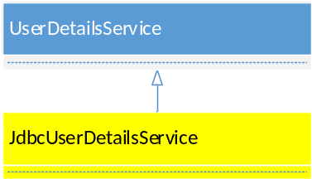
Figure 4.4-2 Authentication Extension - DigestAuthenticationProvider
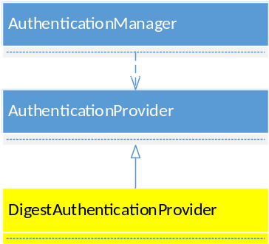

Authorization Extension
‘FileAclService’ (see section 2.2.2.2) in Authorization module is a default implementation of AclService, by loading ACL entries from file, this can be replaced by writing other implementation, eg: ‘JdbcAclService’, by loading ACL entries from database, shown as yellow part in following figure.
Figure 4.5-1 Authorization Extension
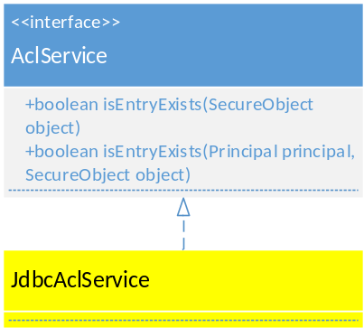

Policy Control Extension
‘FilePolicyService’ (see section 2.2.3) is a default implementation for PolicyService, by loading policy entries from file, this can be replaced by writing other implementation, eg: ‘JdbcPolicyService’, by loading policy entries from database, shown as yellow part in following figure.
Figure 4.6-1 Policy Control Extension
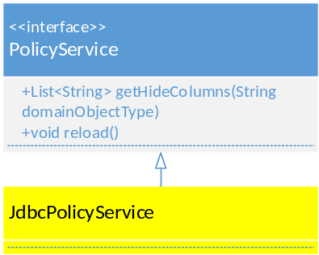

References
[I-D.ietf-weirds-json-response] Newton, A. and S. Hollenbeck, "JSON Responses for the Registration Data Access Protocol (RDAP)", draft-ietf-weirds-json-response-06 (work in progress), October 2013.
[I-D.ietf-weirds-query] Newton, A. and S. Hollenbeck, "Registration Data Access Protocol Query Format", draft-ietf-weirds-RDAP-query-10 (work in progress), February 4, 2014.
[I-D.ietf-weirds-redirects] Martinez, C. and L. Zhou, and G. Rada, "Redirection Service for Registration Data Access Protocol" ,draft-ietf-weirds-redirects-01(work in progress), February 14, 2014.
[I-D.ietf-weirds-bootstrap] Blanchet, M., "Finding the Authoritative Registration Data (RDAP) Service", draft-ietf-weirds-bootstrap-01(work in progress), February 13, 2014.
[I-D.ietf-weirds-RDAP-sec] Hollenbeck, S. and N. Kong, "Security Services for the Registration Data Access Protocol", draft-ietf-weirds-RDAP-sec-05 (work in progress), August 2013.
[RFC3912] Daigle, L., "WHOIS Protocol Specification", RFC 3912,September 2004.
[RFC1035] Mockapetris, P., "Domain names - implementation and specification", RFC 1035, November 1987.
[RFC5891] Klensin, J., "Internationalized Domain Names in Applications (IDNA): Protocol", RFC 5891, August 2010.
[RFC4949] Shirey, R., "Internet Security Glossary, Version 2", RFC 4949,August 2007.

